|  |  |
| --- | --- |
|  | **Emmanuel Catholic College** |
| **Year 9 MATHEMATICS PATHWAY 3** |
| **SEMESTER 1: REVIEW TEST** |

|  |  |
| --- | --- |
| **Name: ___________________________________________________________** | |
| **Working Time: 55 minutes** | **Total Marks: 51** |

##### SEMESTER 1 JUNE 2018

#### 

Time Allowed: Section One = 25 minutes

Section Two = 30 minutes

Instructions to students:-

1. **No Calculators are allowed in Section 1**
2. **Calculators are allowed in Section 2**

**-----------------------------------------------------------------------------------------------**

Total Marks Achieved: _______ = %

**51**

Parent Signature: ________________________________________________________________

**SECTION ONE: NO CALCULATOR ALLOWED**

**Question One (1, 2, 1, 1,1 = 6 marks)**

(a) Determine the value of

(i) $50\% of \$850$

(ii) $45\% of 800$ metres

(b) Round each of the following to the given degree of accuracy:

1. $4.8235$ to 2 decimal places

(ii) $14.38751$ to 3 decimal places

(c) Convert $\frac{5}{8}$ to a percentage

**Question Two (1, 1, 1, 2, 2 = 7 marks)**

(a) Given the expression $3x + 4y - 6$ answer the questions below.

1. Write down the number of terms ________________________
2. What is the coefficient of  *y* . ________________________
3. What is the constant term? ________________________
4. Simplify the following expressions by first collecting like terms:

$$3x + 2 – 4x - 5$$

(c) Expand the following expression.

$-2(2b+c-3a)$

**Question Three (2, 1, 1, 1 = 5 marks)**

Solve for $x$ in the following linear equations

1. 

(b) Solve for $x$ in $4x = 48$

(c) Write an algebraic expression for the following statements:

1. 8 is added to a number n
2. Seventeen is subtracted from six times the number ***r***.

**Question Four (1, 3 = 4 marks)**

(a) **Label** the hypotenuse (H) and adjacent (A) and opposite (O) sides on the triangle below:

A

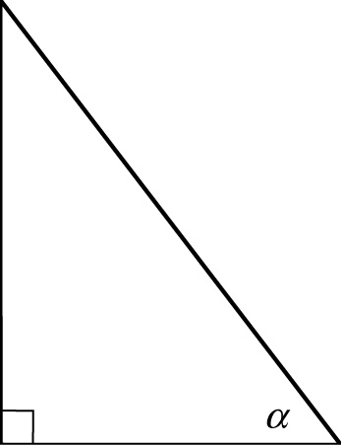

# B C

# If AB = $6 cm$ and BC = $8 cm$ find the length of AC

**Question Five (1, 1 = 2 marks)**

Circle the correct solution for triangle below in each case:

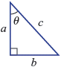

**A**  **B**  **C** 

**D**  **E** 

**A**  **B**  **C** 

**D**  **E** 

**NAME: ___________________________**

**SECTION TWO: RESOURCE RICH**

Question 6 (2, 2, 2, = 6 marks)

Four formulas that apply to simple interest calculations are shown below:

FORMULAE:

$I=P×\frac{r}{100}×t$**OR $I=\frac{P×r×t}{100}$**

$P= \frac{100×I}{r×t}$ $r= \frac{100×I}{P×t}$ $t$ $= \frac{100×I}{P ×r}$

(a) Calculate the amount of simple interest Kate would earn if she invested $12,000 at a rate of 7.5% p.a. for 5 years and 6 months?

(b) Show Michael the number of years that it would take for $60,000 to earn $16,200 of simple interest when it is invested at 9% p.a.

(c) At what percentage rate would Jake need to invest his savings of $450, if he wanted to earn $108 simple interest at the end of 2 years?

Question 7 (2, 2 = 4 marks)

(a) Use Pythagoras’ theorem to determine the value of the unknown in each triangle below. Round your

answers to 2 decimal places.

(i)

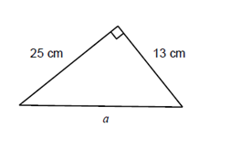

***w***

(ii)

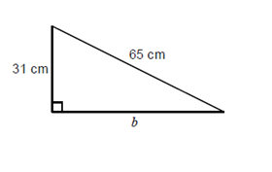

***y***

Question 8 (2, 2, 2 = 6 marks)

A ladder that is 15m in length is leaning against a wall. The ladder reaches 13m up on the wall.

1. Show this situation in a labelled diagram below.
2. Calculate how far the base of the ladder is from the wall (CORRECT TO 1 DECIMAL PLACE).
3. Find the angle that the ladder makes with the horizontal ground (TO THE NEAREST DEGREE).

Question 9(2, 2, 2 = 6 marks)



Determine the value of the *pronumeral* in each of the following diagrams. Round your answers to 1 decimal place. **Working out must be shown in order to achieve full marks.**

Note: Diagrams are NOT drawn to scale.

(a)

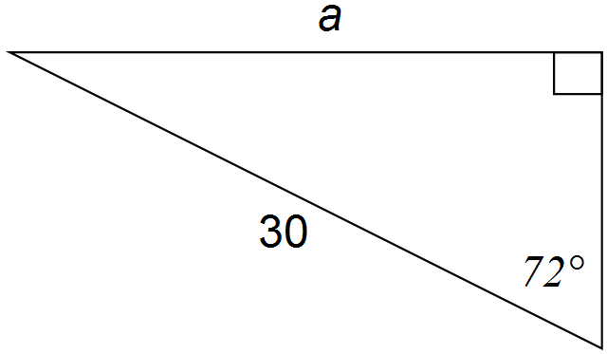

(b)

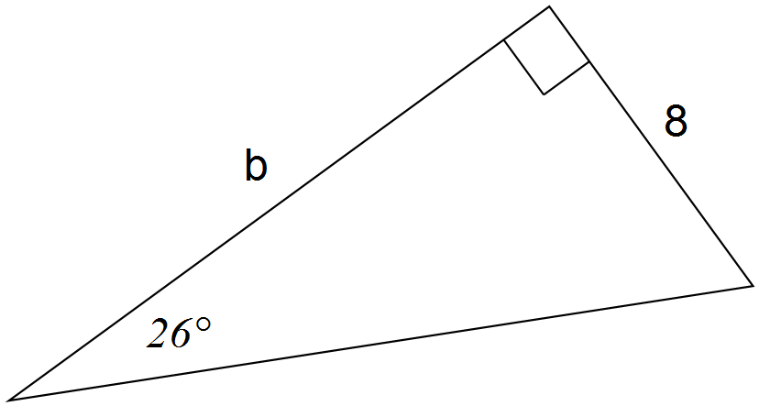

*y*

(c)

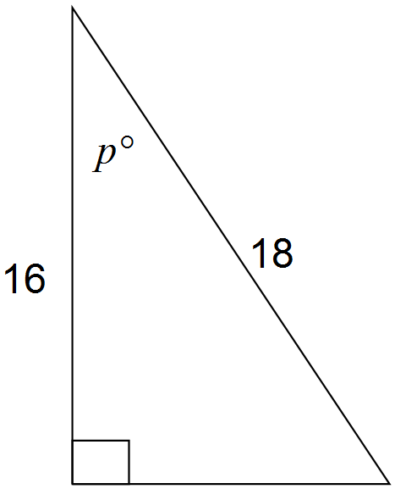

**Question 10 (5 marks)**

A car and a truck are parked on opposite sides of a building that stands 15 metres high.

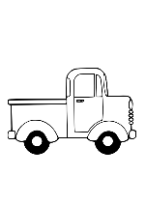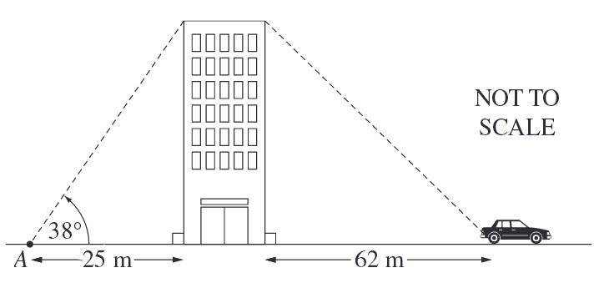

**18 m**

***y***

***x***

Using the information above, determine which vehicle is parked further away from the base of the building. Show full working!

END OF TEST