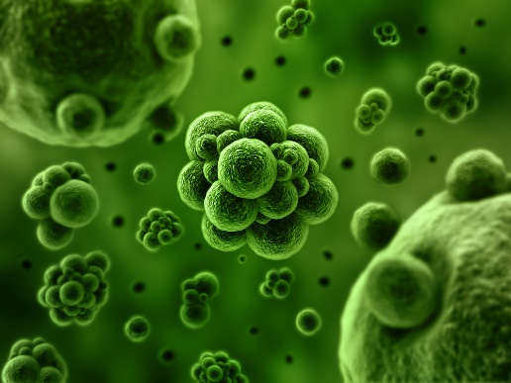
Pathogens and Disease
- Use the Internet to locate a definition of the words pathogen and disease and list them below in your own words.

Disease
Internet description
My own understanding
Pathogen
Internet description
My own understanding

- Make a list of all the diseases you can think of in 5 minutes in the 1st column. Then divide them up into 2 categories, infectious (spreadable) and non-infectious (not spreadable)
Non-Infectious Diseases
Infectious Diseases
Diseases that I know

- Research using the Internet and create a pathogen infographic or poster about the different types of pathogens we can experience. Your graphic must include:
- 5 types of pathogens
- List 3 diseases each pathogen can cause
- Include a scaled photo of each pathogen

