Letter | Characteristic produced by Mutation
A | Extremely long fingernails (tape wooden craft sticks to fingers) | 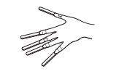
B | No fingers (tape each hand closed) | 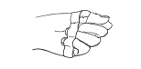
C | Lack of peripheral vision (attach cottonwool to sides of goggles) | 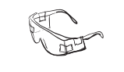
D | Hands fused together in front of body (place hands together in front of body and gently tie them together) | 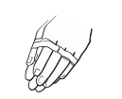
E | Short stride (tie string gently around ankles) | 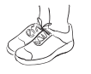
F | No arms (gently tie arms to the side of body with string) | 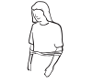
G | Arms fused together behind back (place arms behind back do not tape or tie hands) | 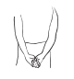
H | Blind (cover eyes with hand) | 